**Yes** !!

EPI valve Texas does pipeline field service work, AND

EPI valve Texas is moving into power plant valve maintenance work.

Gate valves parallel slide pressure seal bonnet

Globe valves

Control valves including Fisher, CCI, and others

Stop check valves pressure seal bonnet.

Electric actuators

Pneumatic actuators we can repair most brands

We can tube up actuators mount limit switches

.

We have an EFCO machine to grind and lap seats in valves up to 18''.

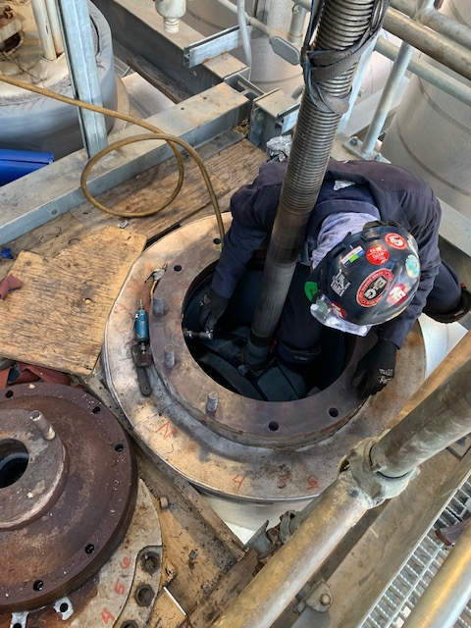 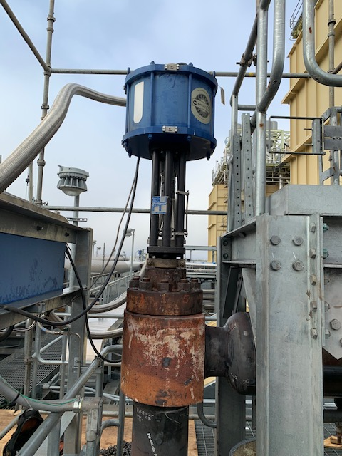

CALL US TODAY!

CHARLIE PRATHER - SALES AND SERVICE MANAGER 832-628-9126

BILLY STARK – OPERATIONS MANAGER 713-897-1649

ROY LEE HENRY – SENIOR SERVICE TECHNICIAN 832-752-9381

CRYSTAL CHAPMAN – SALES MANAGER – 281-636-6045

Thanks very much for your interest in working with EPI Valves Texas LLC. EPI is a complete valve manufacturing and repair facility with all the necessary capabilities to support your efforts. We repair valves in our shop or at our customers location depending on the circumstances. We have six experienced technicians that can work in the shop and three that can perform field service. We have two service trucks fully equipped to support our field service efforts and a machine to do seats and machining on valves in line. We work all over the United States and Internationally to support our customer base.

EPI is a manufacturer of new through conduit parallel expanding gates and through conduit slab gate valves. We also supply many other types of valves to the customer through our distribution channels. We support all types of valves and actuators. We are a complete repair facility for all types of valves and actuators. We are certified by API for Pipeline Gate Valves according to standard API 6D. We also operate according to the API Q1 Quality system.

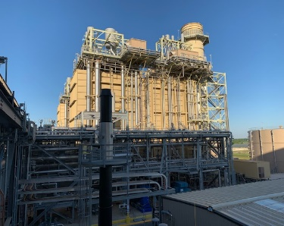 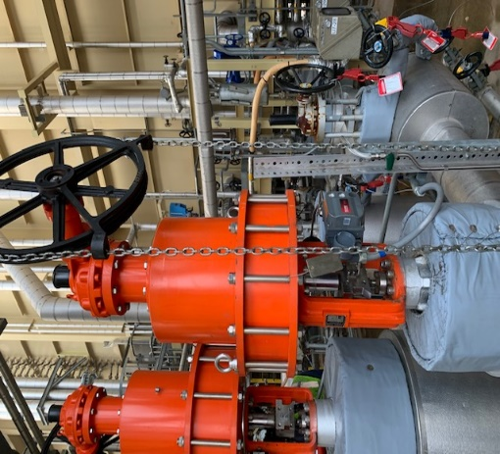 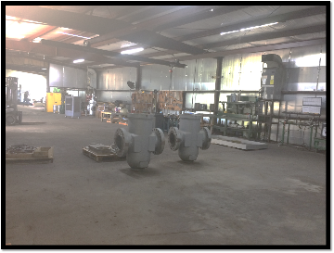

CALL US TODAY!

CHARLIE PRATHER - SALES AND SERVICE MANAGER 832-628-9126

BILLY STARK – OPERATIONS MANAGER 713-897-1649

ROY LEE HENRY – SENIOR SERVICE TECHNICIAN 832-752-9381

CRYSTAL CHAPMAN – SALES MANAGER – 281-636-6045